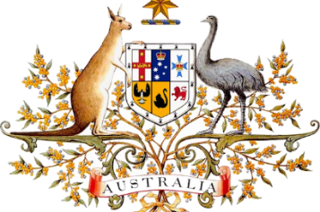
Federation

Beginnings
From the late 1700s British colonies were founded in Australia. In 1901, these colonies (New South Wales, Victoria, Queensland, South Australia, Western Australia and Tasmania) came together and formed the nation of Australia through a process known as federation.
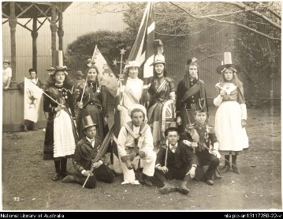
Before 1901 Australia did not exist as a nation. The six British colonies were like six separate countries. Each colony had a parliament that could make laws, but was still subject to the authority of the British Parliament. Each had its own defence force, issued its own stamps and collected tariffs (taxes) on goods that crossed its borders. The colonies even had different railway systems.

WHY FEDERATE

Path to federation
Before the colonies could unite, they had to agree how federation would work and make sure it was fair for everyone. Federation would require that each colony give some of their powers to a national parliament. The colonies decided they needed a set of rules, or constitution, for how Australia should be run.

One destiny for the nation
The nation of Australia came into being on 1 January 1901 at a ceremony held in Centennial Park in Sydney. During the ceremony, the Governor-General, Lord Hopetoun, was sworn in. Then Australia’s first Prime Minister, Sir Edmund Barton, and federal ministers took the oath of office.
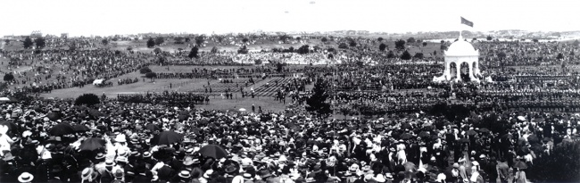+
Australians celebrate federation at Centennial Park, Sydney

Answer these questions in your notes:
- How many British colonies were there in Australia before 1901?
- On what date did Australia become a nation?
- What is the Australian Constitution?
- What was the name of Australia’s first Prime Minister?

